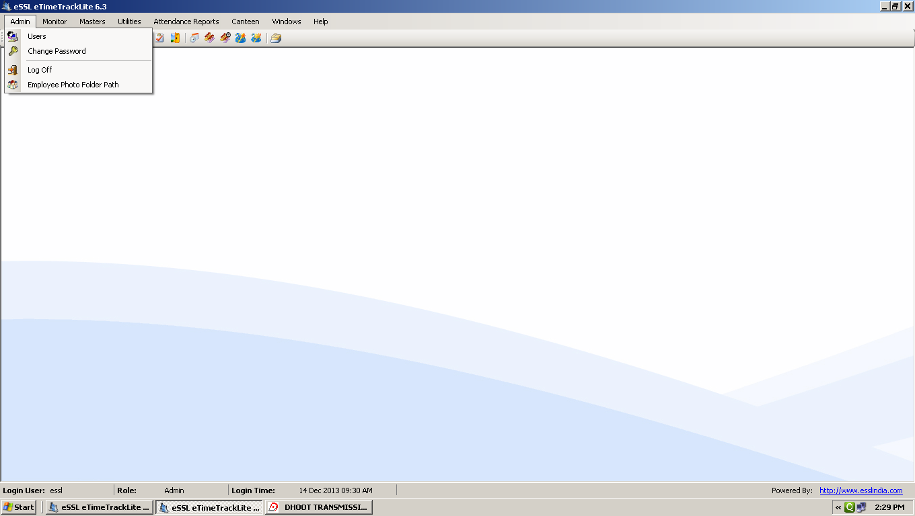
Fig. Admin Menu

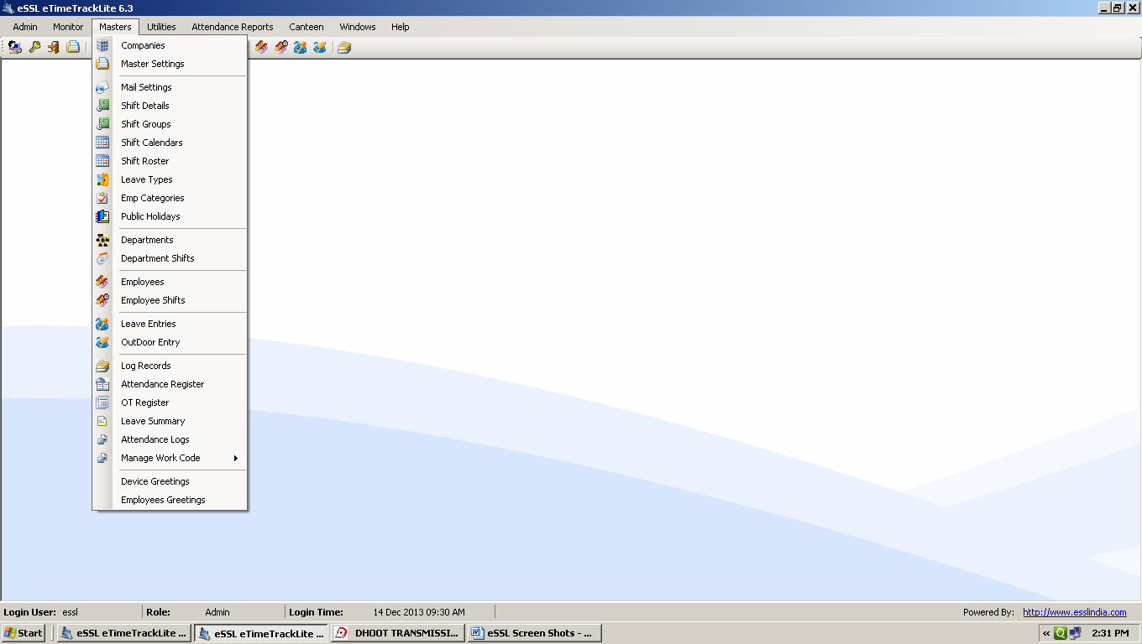
Fig. Masters Menu

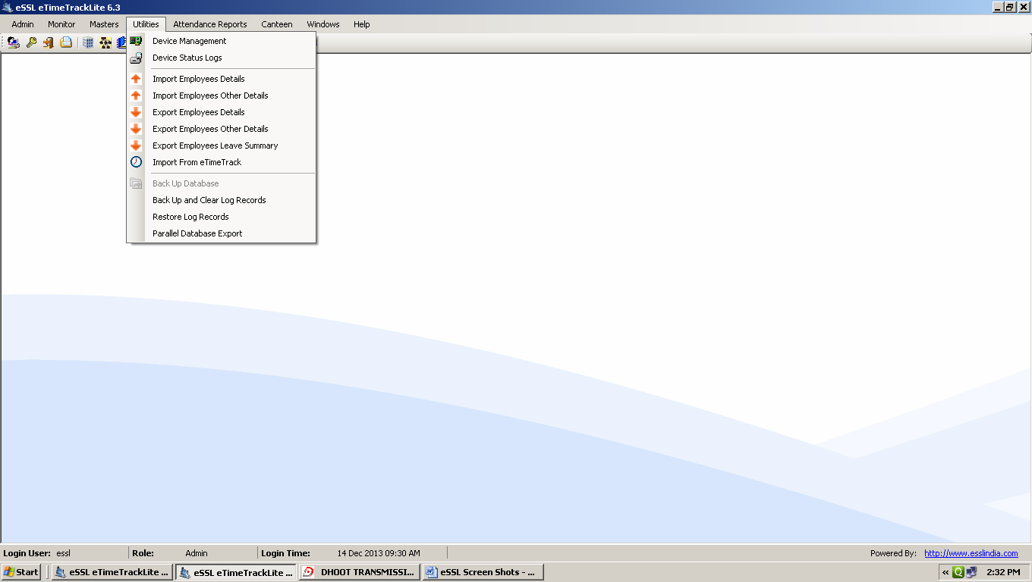
Fig. Utilities Menu

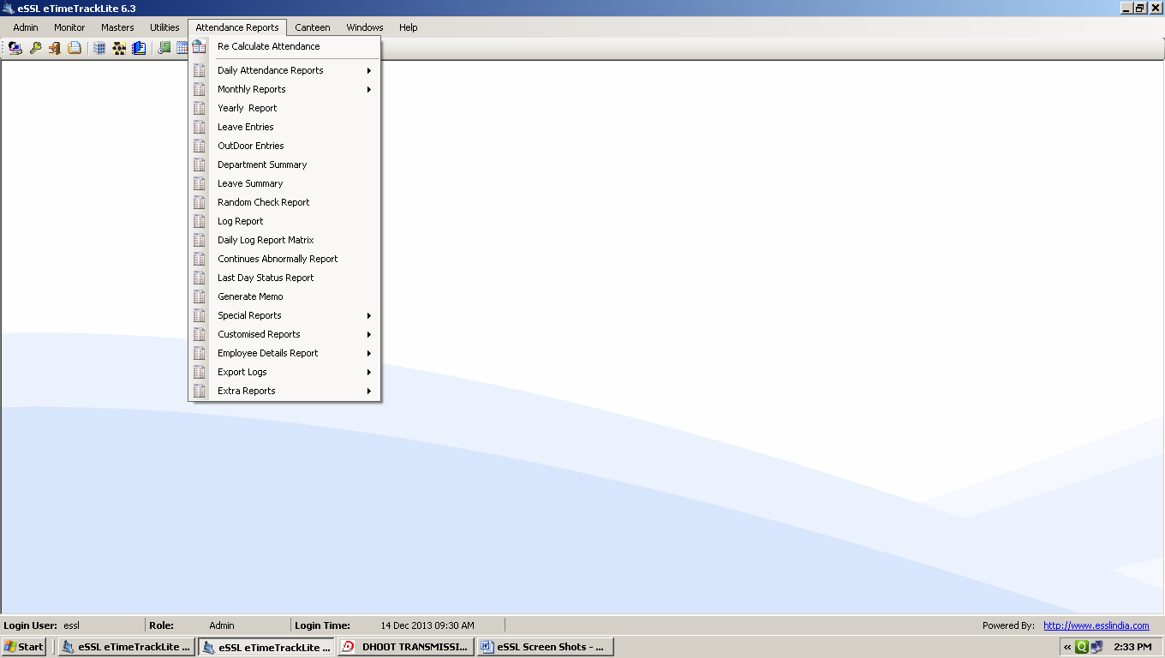
Fig. Attendance Reports Menu

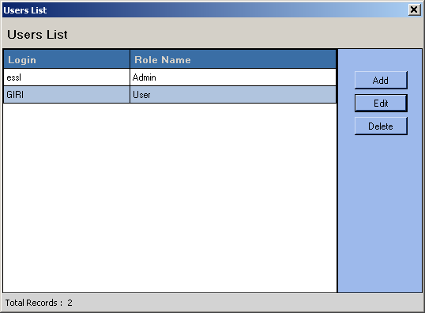
FIG. USER LIST

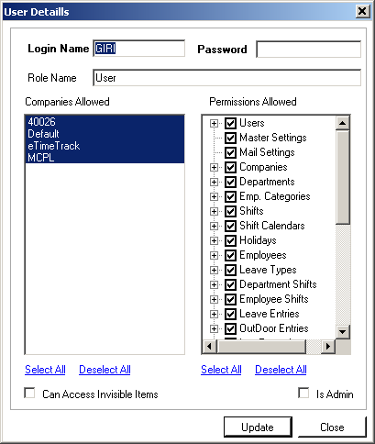

FIG. USER DETAILS

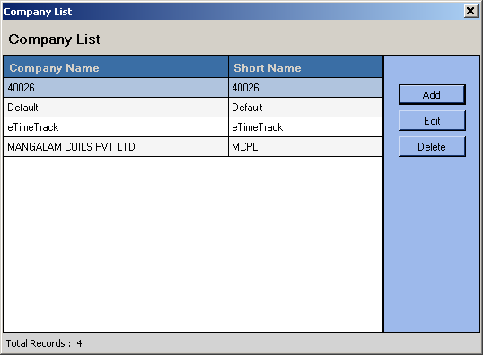
FIG. COMPANY LIST

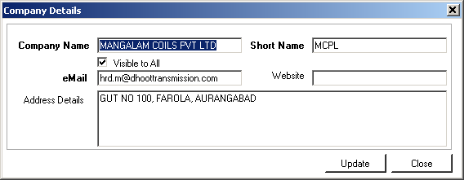
FIG. COMPANY DETAILS

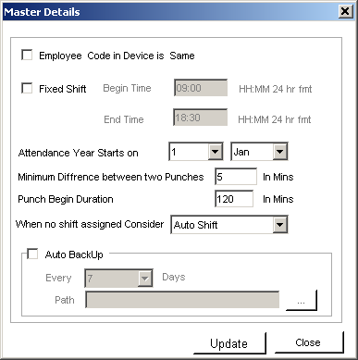
FIG. MASTER DETAILS

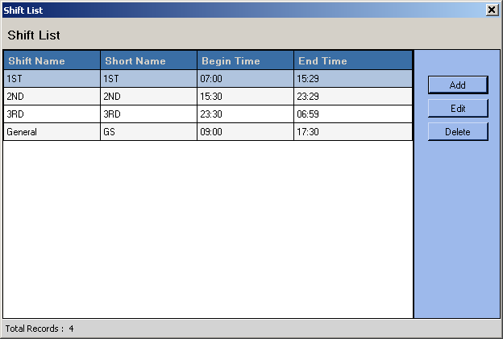
FIG. SHIFT LIST
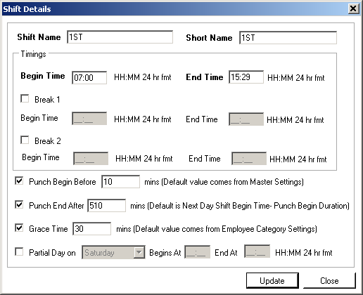
FIG. SHIFT DETAILS

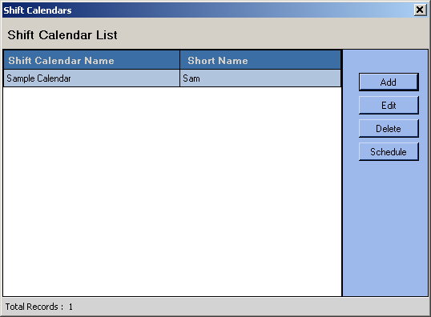
FIG. SHIFT CALENDARS

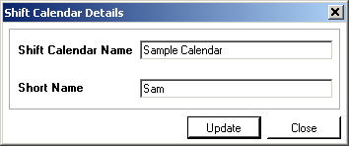
FIG. SHIFT CALENDAR DETAILS

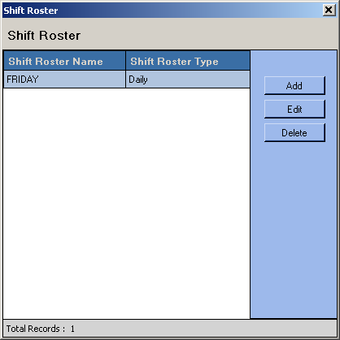
FIG. SHIFT ROASTER

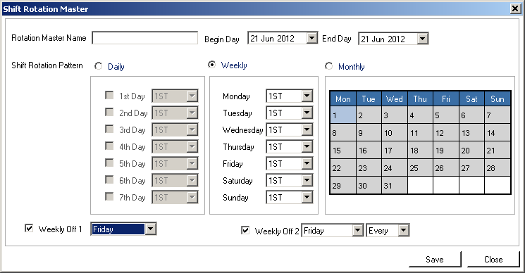
FIG. SHIFT ROTATION MASTER

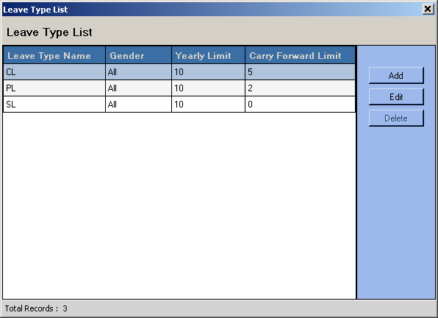
FIG. LEAVE TYPE LIST

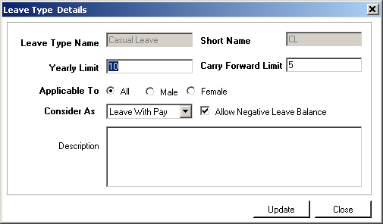
FIG. LEAVE TYPE DETAILS

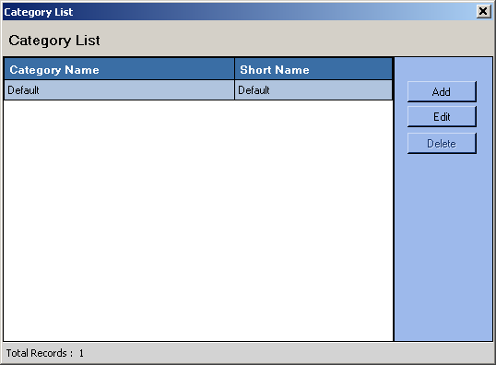
FIG. EMPLOYEE CATEGORY LIST

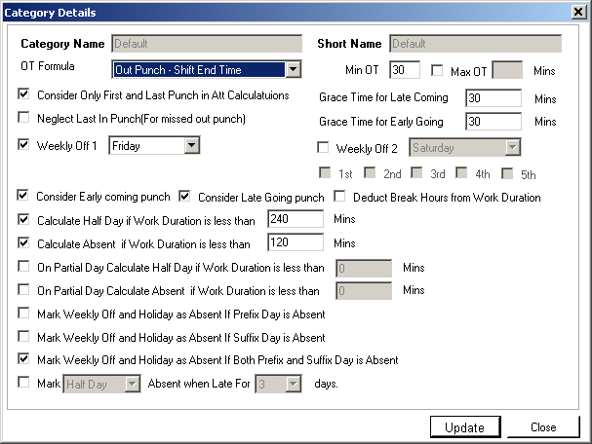
FIG. CATEGORY DETAILS (1)

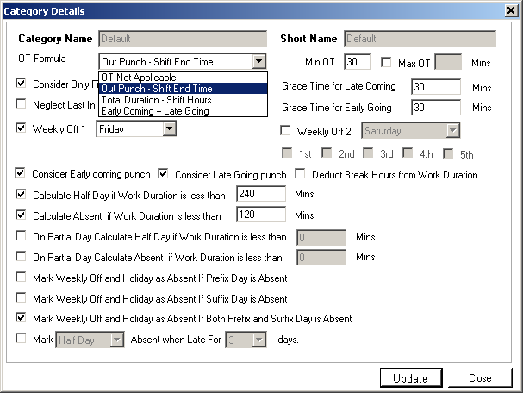
FIG. CATEGORY DETAILS (2)

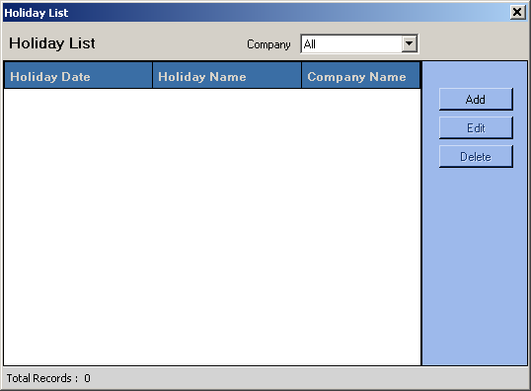
FIG. HOLIDAY LIST

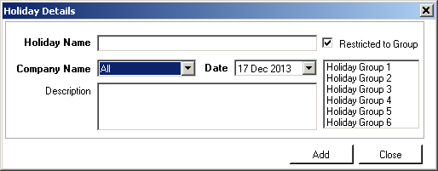
FIG. HOLIDAY DETAILS

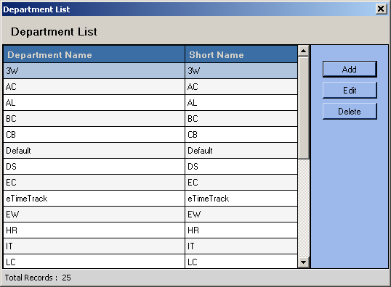
FIG. DEPARTMENT LIST

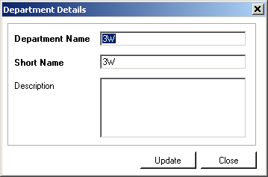
FIG. DEPARTMENT DETAILS

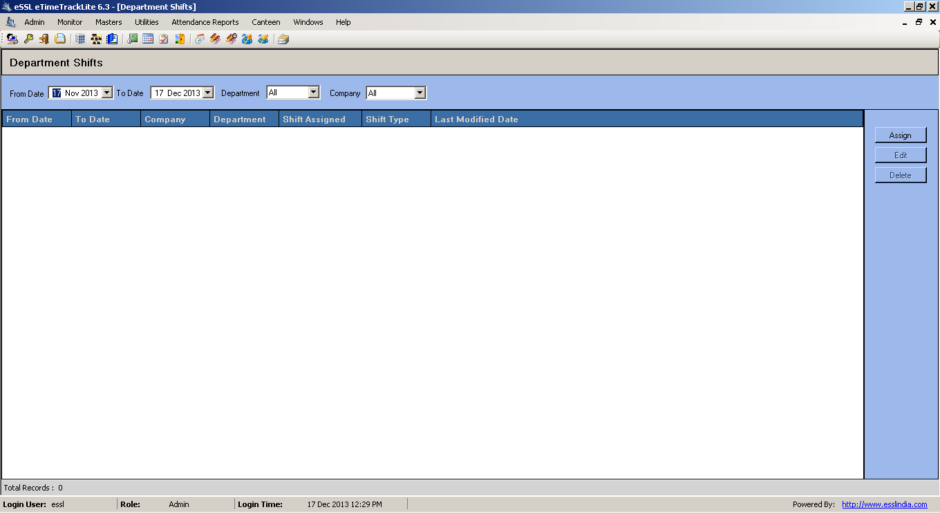
FIG. DEPARTMENT SHIFTS

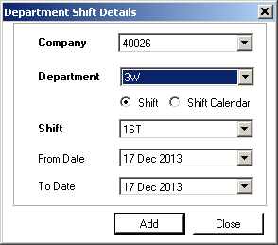
FIG. DEPARTMENT SHIFT DETAILS

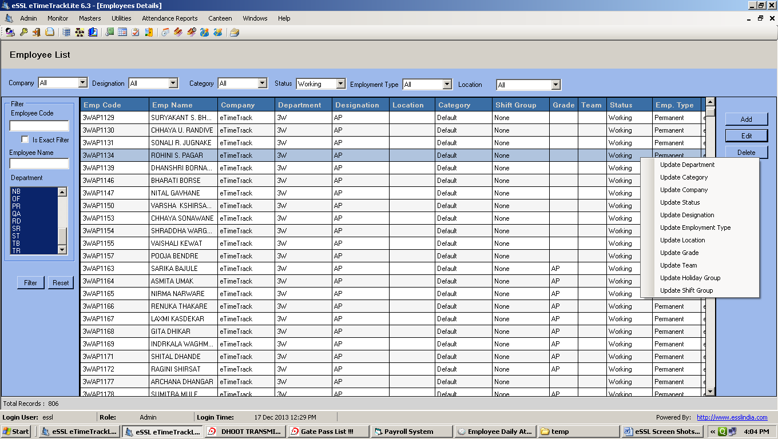
FIG. EMPLOYEE LIST

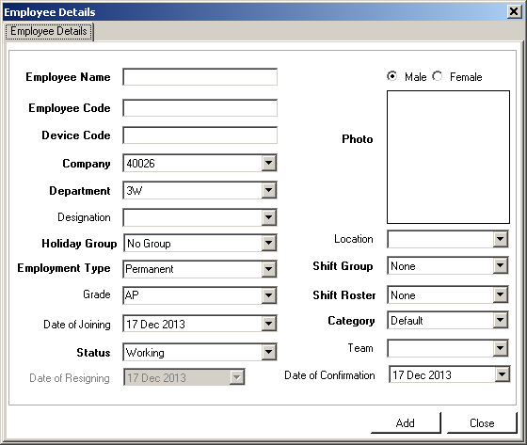
FIG. ADD EMPLOYEE

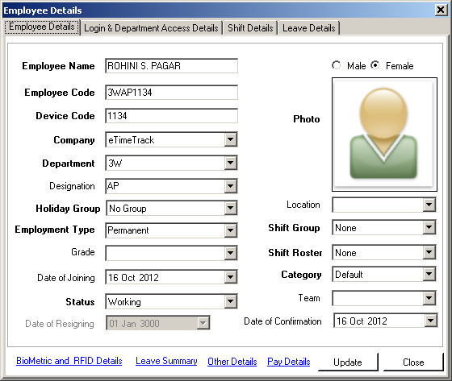
FIG. MODIFY EMPLOYEE DETAILS PAGE -1

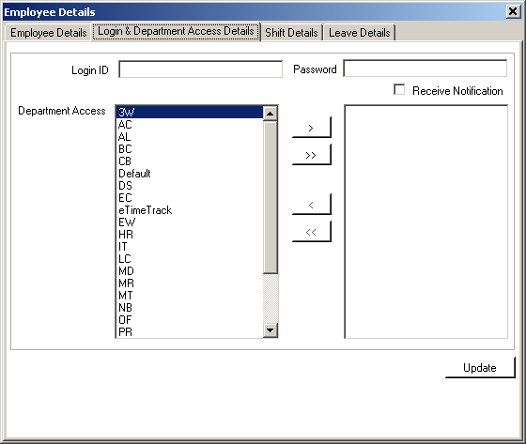
FIG. EMPLOYEE DETAILS PAGE 2

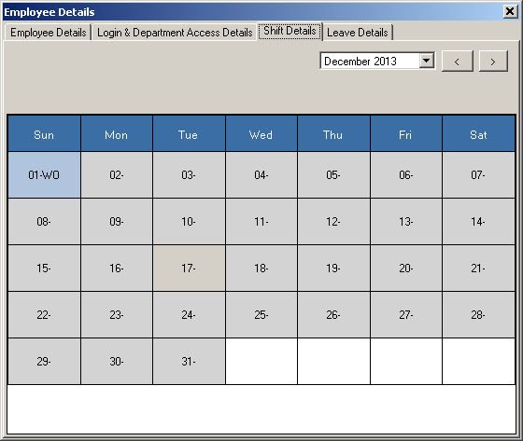
FIG. MODIFY EMPLOYEE DETAIL PAGE 3

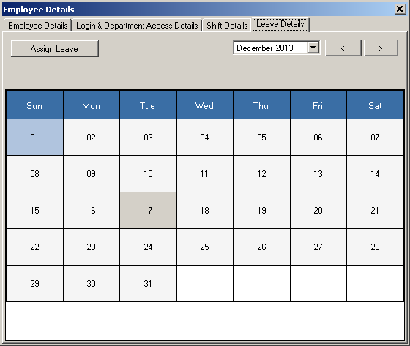
FIG. MODIFY EMPLOYEE DETAIL PAGE 4

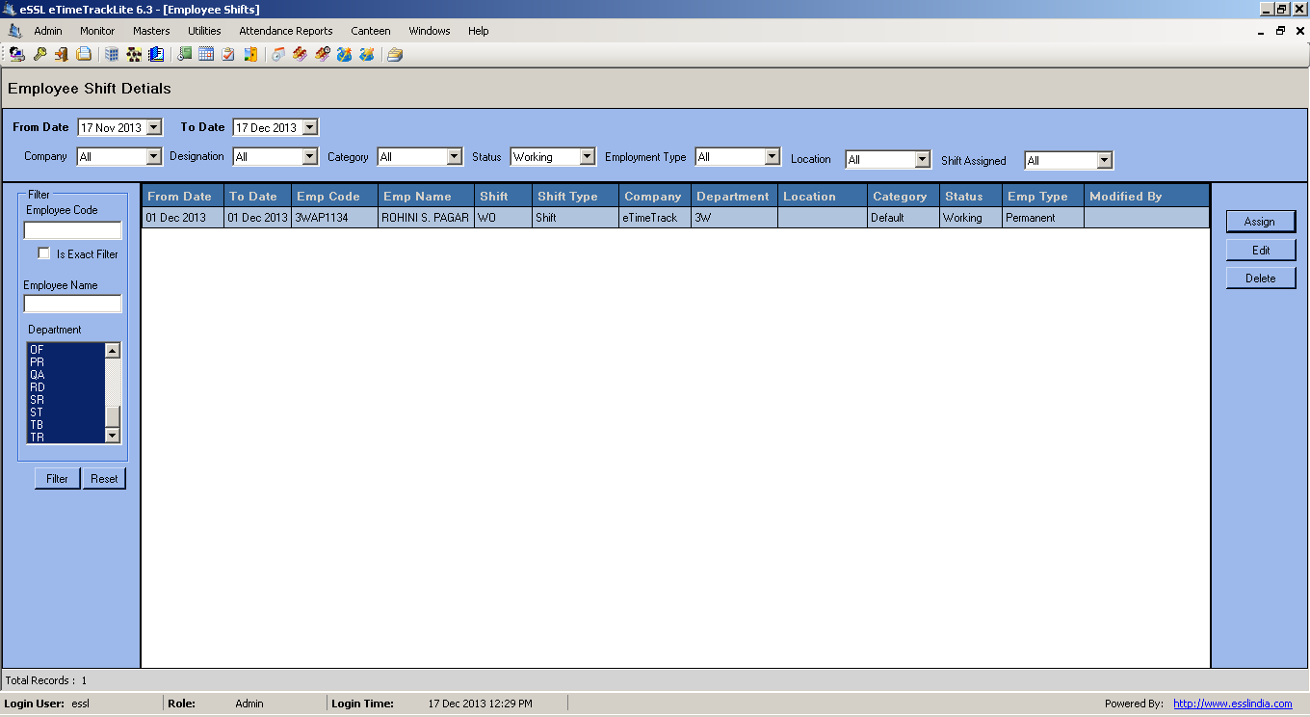

FIG. EMPLOYEE SHIFT DETAILS

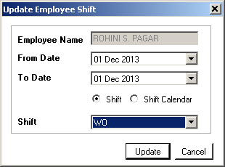

FIG. UPDATE EMP. SHIFT

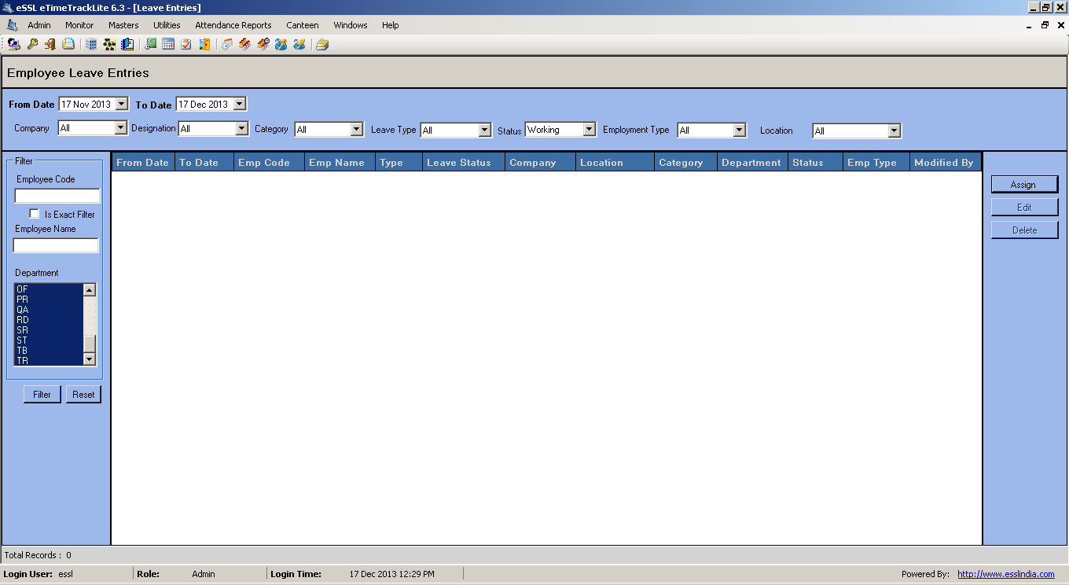
FIG. EMPLOYEE LEAVE ENTRIES

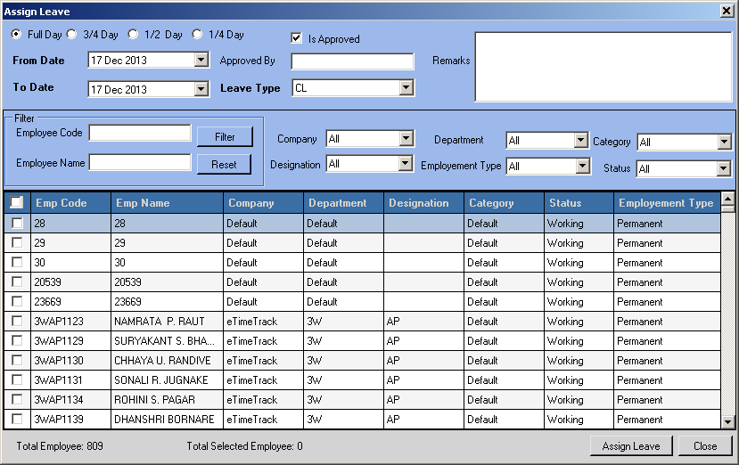
FIG. ASSIGN LEAVE

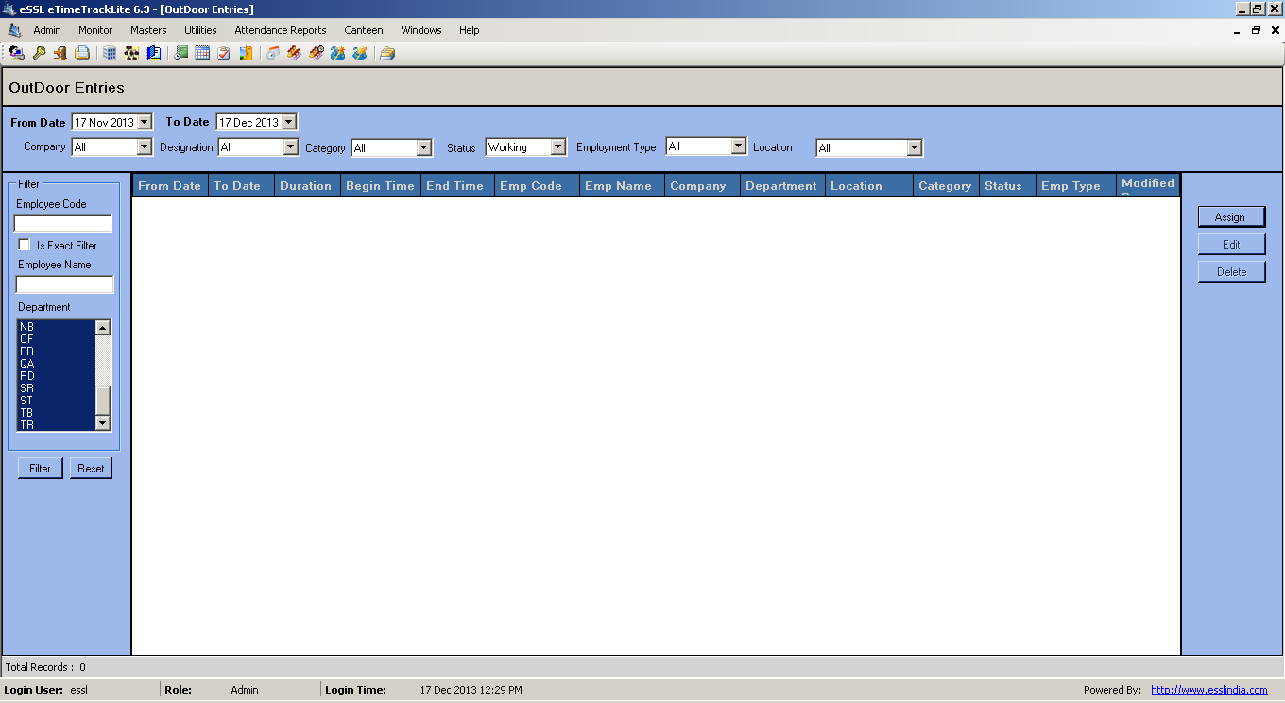
FIG. OUTDOOR ENTRIES

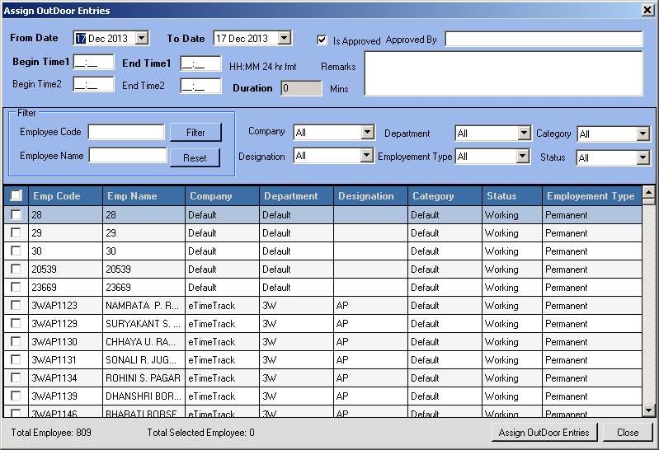
FIG. ASSIGN OUTDOOR ENTRY
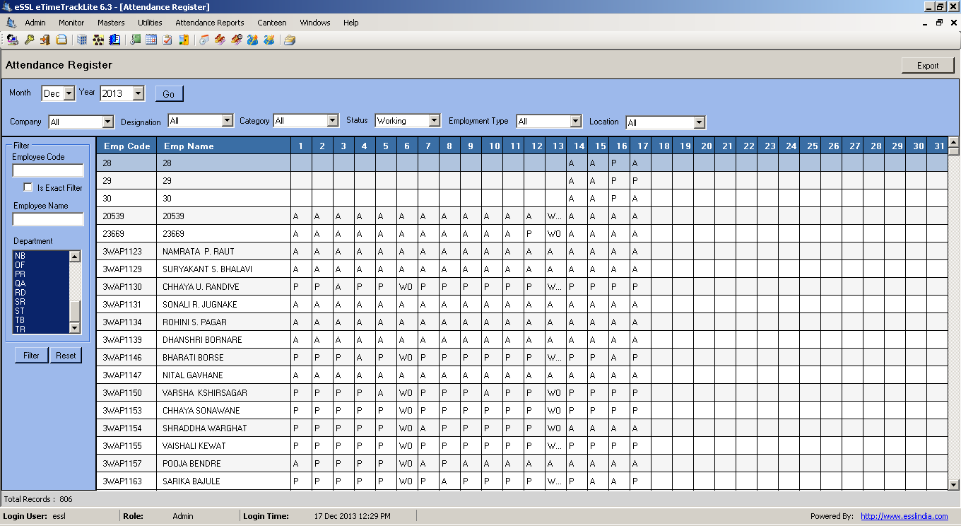
FIG. ATTENDANCE REGISTER

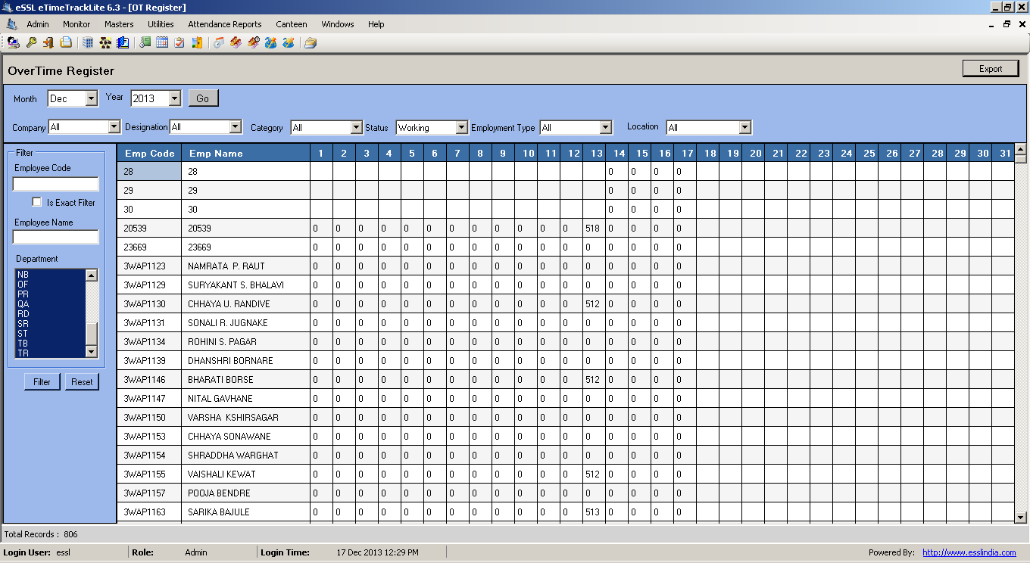
FIG. OVERTIME REGISTER

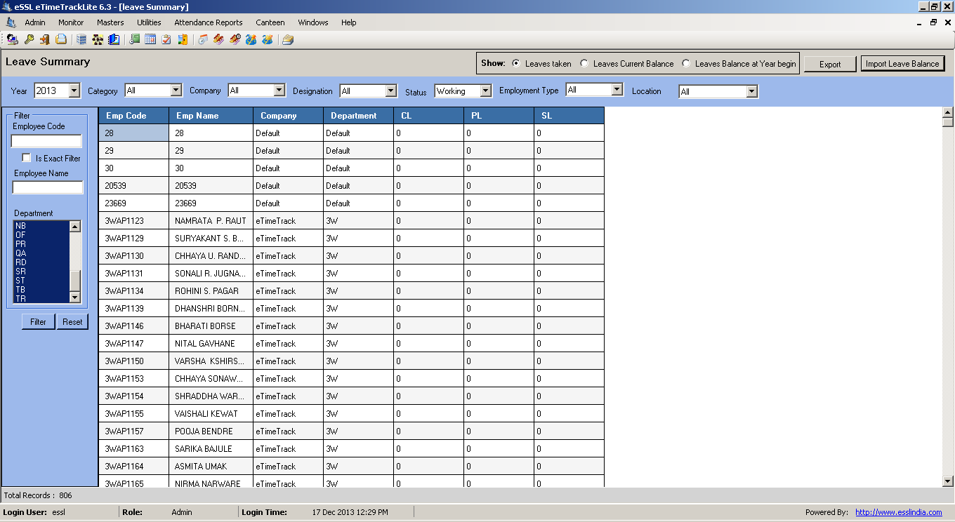
FIG. EMPLOYEE LEAVE SUMMARY

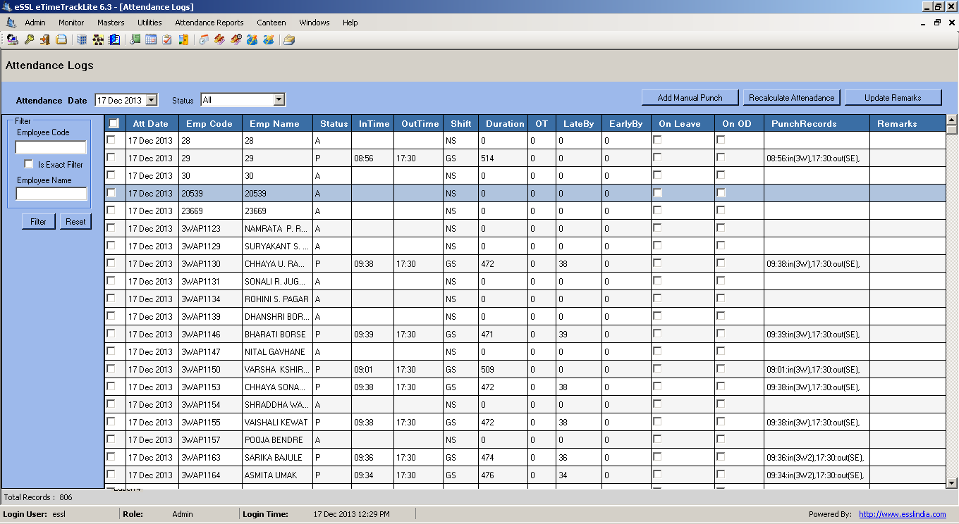
FIG. ATTENDANCE LOGS

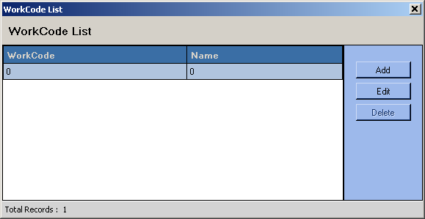
FIG. WORK CODE LIST

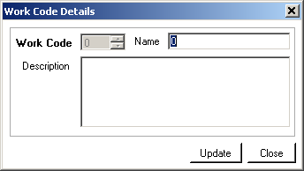
FIG. WORK CODE DETAILS

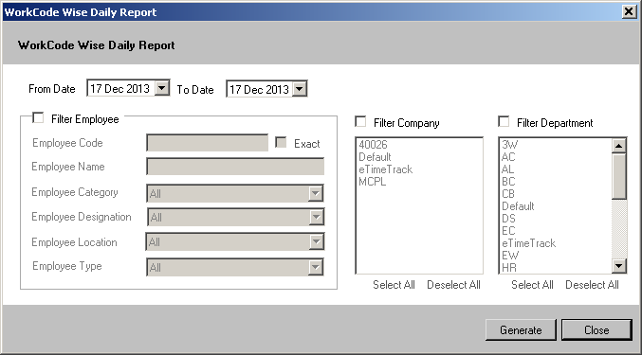
FIG. WORK CODE WISE DAILY REPORT

WORKCODE WISE SUMMARY REPORT

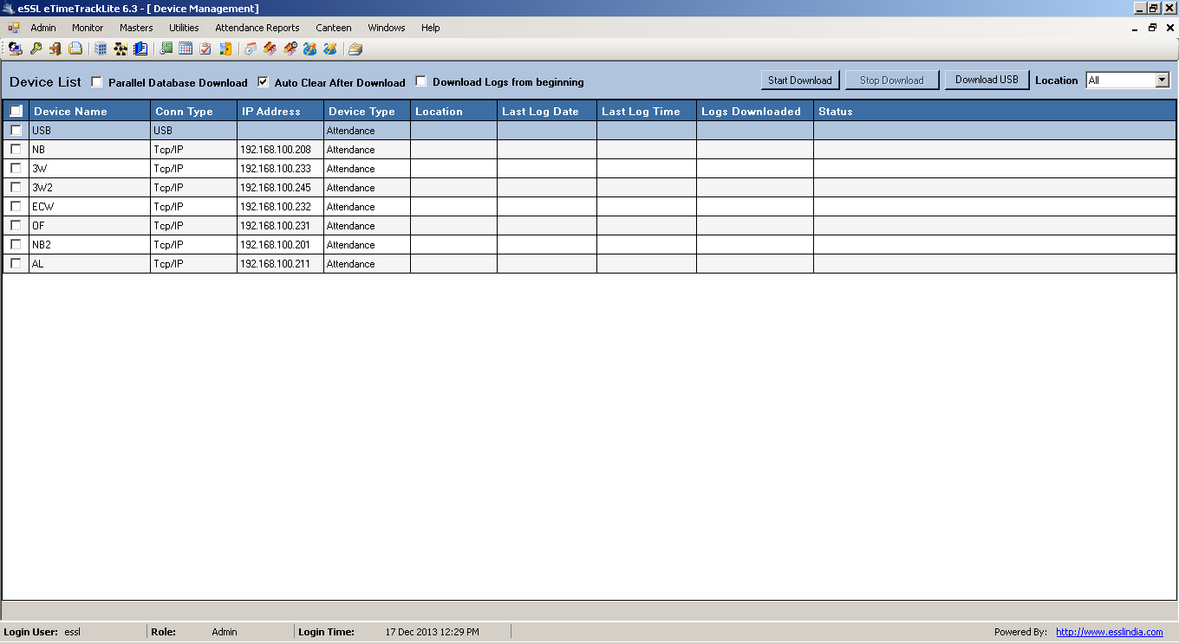
FIG. DEVICE MANAGEMENT

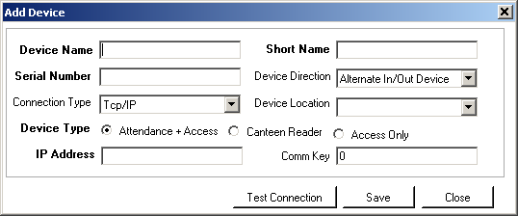
FIG. ADD DEVICE

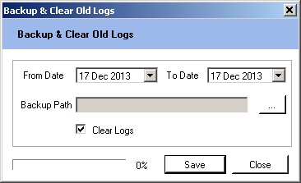
FIG. BACKUP AND CLEAR LOGS

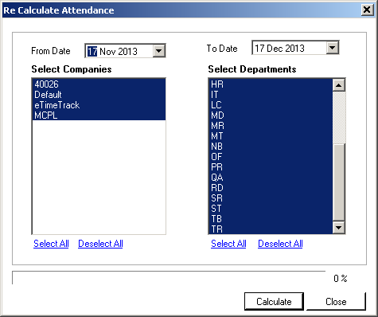
FIG. CALCULATE ATTENDANCE

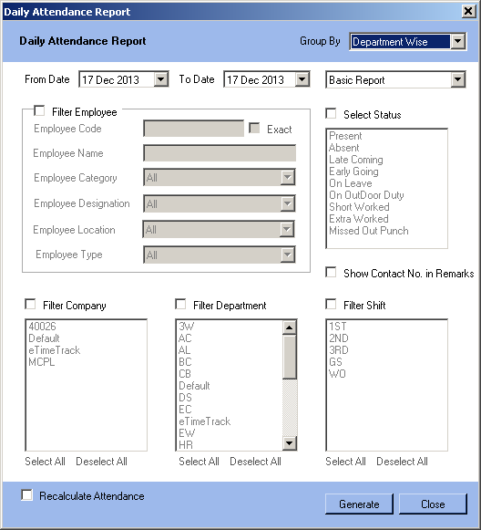
FIG. ATTENDANCE REPORT PARAMETERS

